April 3 – April 5, 2020
All the information on this form can be found on our website at www.childrenchangetheworld.com

Permission: By registering for this Conference, you are giving permission that your photograph may be taken to be used in legitimate purposes by any of the event holder, sponsors, organizers, etc.

Attendees with Special Needs: The conference is held in a wheelchair accessible facility.

Dietary Needs: If you have any specific dietary restrictions, please specify: ________________________

If you have any other questions or concerns, please contact Shelley Debaar at debaar@montessoriway.ca

Your Name and Organization as you would like it to appear on your Conference Badge:
First Name:
Last Name:
Organization:

Contact Information:
(____)__________________ (____)_________________ _____________________________________
Work Phone Home or Cell Phone E-Mail (required for registration confirmation)

____________________________________________________________________________________________________________________
Name (first and last, please specify if you are called by a nickname, e.g. Katherine vs. Kate)

_____________________________________________________________________________________________________________________
Street Address Apt. or Suite Number □ Home or □ Business

_____________________________________________________________________________________________________________________
City State or Province ZIP or Postal Code Country

 | Early Bird (through 01/31/2020) | Regular (02/01/2020-03/11/2020)
3-Day (Fri, Sat& Sun) | $400.00 | $475.00

Accommodations are the responsibility of the attendee; the conference is being held at the Sheraton Cavalier and there is a link on the website to connect you directly to them to make your reservations. Meals are provided with your registration

Payment and Cancellation Policy Agreement:

By signing below, you agree to the terms and conditions of the cancellation and payment policy. Cancellation Policy: Requests for refunds must be sent in writing by e-mail, post mail or faxed. There will be a $100.00 cancellation fee that will be debited from the refund. The deadline to cancel is February 15, 2020.

Total Fee: $______________

□ Enclosed is my check or money order for the Total Fee of $_____________
(Payable to Montessori Children’s House Academy (MCHA) in Canadian Dollars with a Canadian Bank Only)

□ Paypal – button located on the website

□ Etransfer to campus1@montessoriway.ca – use the password CCWMC2020

This is wonderful weekend of Montessori liked minded individuals getting together to share and learn from each other. It is our pleasure to host this conference and to be able to provide you with a relaxing weekend, where time slows down and someone takes care of you.

Please plan to take in the full experience and join us for meals, entertainment and the different networking opportunities that are available throughout the weekend, some are planned and some just wonderfully happen.

We want the conference to not only be about the knowledge sharing but about a full experience of a weekend with great people, great food, great knowledge, great sharing, rest and relaxation and so much more.

Consider staying right at the hotel for the weekend, you deserve it and it will just add to your experience.

Shelley and Blair Debaar and the entire Conference team

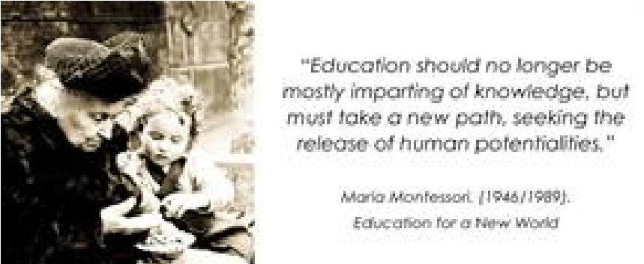

Exhibitors and Sponsors please select that tab to learn more information

Breakout Selection Please indicate first, second and third choice for each

MORNING SESSION Saturday April 4th, 2020 (10:00am – 11:15am)
What will you be attending - Please circle Yes or No
Friday April 3
Welcoming Session/Keynote – Yes No
Saturday April 4
Sunrise Yoga Yes No
Continental Breakfast Yes No
Lunch Yes No
Dinner/Entertainment Yes No
Sunday April 5
Sunrise Yoga Yes No
Continental Breakfast Yes No
Lunch Yes No
We ask that you only register for Sunrise Yoga if you are going to attend it.

Our Keynotes for Weekend:

Friday April 3 – 7:00pm to 8:00pm -Teach Empathy and Create Compassionate World.
Another plug for kindness. ​​ Tajali Tolan

Saturday April 4 – 8:45am to 9:45pm –Nurturing the spirit through out interaction with nature and the world, according to Montessori – Jana Morgan Herman

Saturday April 4 – 12:00pm – 1:00pm - Within the story and the story within – Kyle Herman

Sunday April 5 – 9:00am – 10:00am – Creating long -lasting impressions: The truth about tours - Tammy Oesting

Sunday April 5 – 1:55pm – 2:55pm - The “Enigmatic” Teacher guide – Daniel Jutras

Choice #
____ 1 Acclimate support staff to Montessori environments – Tammy Oesting
____ 2 Discipline Techniques – Naomi Faroogh
____ 3 The universe story in secondary education – Kyle Herman (elementary)
____ 4 Transformative Observation – Andrea Lulka and Regina Lulka
____ 5 Auditing the Library – Ashley Speed and D. Ann Williams

AFTERNOON SESSION Saturday April 4th, 2020 (1:30pm – 3:00pm)
Choice #
____ 1 Xylophoni Maccaroni – Awakening the voice of a young child – Al Hirsch
____ 2 The mystery bag of tricks – Jayanthi Rajagopalan
____ 3 The Unveiled Power of the Simple Colored Beads - Daniel Jutras
____ 4 Inclusive Classroom – Naomi Faroogh
____ 5 Montessori and the importance of outdoor classroom, according to her – Jana Morgan Herman
____ 6 Montessori Practices that Teach Mindfulness and Peace. Shelf Work, Yoga and Peace Circles –
Tajali Tolan

AFTERNOON SESSION Saturday April 4th, 2020 (3:10pm – 4:40pm)
Choice #
____ 1 Cultivating Community through Rhythm Games - Tammy Oesting
____ 2 Conundrums of Circle Time - Anahita Faroogh
____ 3 Sensory Fun: Get Out the Goop – Creative Childcare
____ 4 Preparation of the Curricular environment – Claudia Mann (Elementary I and II)
____ 5 Developing thermic units/studies - Lori Karmazin

AFTERNOON SESSION Saturday April 4th, 2020 (4:50pm – 6:00pm)
____ 1 Gathering of Administrators
____ 2 Let’s create a nomenclature – Non instructed – materials provided to create
____ 3 Music Exploration – Carolina Slim

MORNING SESSION Sunday April 5th, 2020 (10:00am – 11:15am)
Choice #
____ 1 Playing with Sensorial - Jayanthi Rajagopalan
____ 2 Control or Character? How discipline leads to peace – Andrea Lulka and Regina Lulka
____ 3 Laughter & Children's Yoga culture - Anahita Faroogh
____ 4 Decentring Cis/Het in the school community: The Directress and Administrators role – Ashley
Speed and D. Ann Williams
____ 5 Expanding writing opportunities with the moveable alphabet - Lori Karmazin

AFTERNOON SESSION Sunday April 5th, 2020 (12:15pm – 1:45pm)
Choice #
____ 1 Getting Back to Nature: Nature Art – Creative Child Care
____ 2 Music, Movement and Folk Dances for Children – Daniel Jutras
____ 3 Get out Rock! – Claudia Mann (Elementary I and II)
____ 4 Stories of Childhood – Storytelling with young children – Al Hirsch
____ 5 The seven elements of art and sensorial materials as Montessori describes it – Jana Morgan Herman

Mail: Fax: Email Questions:
MCHA 1-403-726-1132 debaar@montessoriway.ca 403-863-3229
108, 2411 – 4th St NW
Calgary, Alberta T2M 2Z8

