March 3 – March 5, 2023
All the information on this form can be found on our website at www.childrenchangetheworld.com

Permission: By registering for this Conference, you are giving permission that your photograph may be taken to be used in legitimate purposes by any of the event holder, sponsors, organizers, etc.

Attendees with Special Needs: The conference is held in a wheelchair accessible facility.

Dietary Needs: If you have any specific dietary restrictions, please specify: ________________________

If you have any other questions or concerns, please contact Shelley Debaar at debaar@montessoriway.ca

Your Name and Organization as you would like it to appear on your Conference Badge:
First Name:
Last Name:
Organization:

Contact Information:
(____)__________________ (____)_________________ _____________________________________
Work Phone Home or Cell Phone E-Mail (required for registration confirmation)

____________________________________________________________________________________________________________________
Name (first and last, please specify if you are called by a nickname, e.g., Katherine vs. Kate)

_____________________________________________________________________________________________________________________
Street Address Apt. or Suite Number □ Home or □ Business

_____________________________________________________________________________________________________________________
City State or Province ZIP or Postal Code Country

 | Early Bird (through 01/31/2023) | Regular (02/01/2023-02/17/2023)
3-Day (Fri, Sat& Sun) | $500.00 | $575.00

Accommodations are the responsibility of the attendee; the conference is being held at the Sheraton Cavalier and there is a link on the website to connect you directly to them to make your reservations. Meals are provided with your registration

Payment and Cancellation Policy Agreement:

By signing below, you agree to the terms and conditions of the cancellation and payment policy. Cancellation Policy: Requests for refunds must be sent in writing by e-mail, post mail or faxed. There will be a $100.00 cancellation fee that will be debited from the refund. The deadline to cancel is February 1, 2023.

Total Fee: $______________

□ Enclosed is my check or money order for the Total Fee of $_____________
(Payable to Montessori Children’s House Academy (MCHA) in Canadian Dollars with a Canadian Bank Only)

□ PayPal – button located on the website

□ Etransfer to campus1@montessoriway.ca – use the password CCWMC2023 if needed

This is wonderful weekend of Montessori liked minded individuals getting together to share and learn from each other. It is our pleasure to host this conference and to be able to provide you with a relaxing weekend, where time slows down and someone takes care of you.

Please plan to take in the full experience and join us for meals, entertainment and the different networking opportunities that are available throughout the weekend, some are planned and some just wonderfully happen.

We want the conference to not only be about the knowledge sharing but about a full experience of a weekend with great people, great food, great knowledge, great sharing, rest and relaxation and so much more.

Consider staying right at the hotel for the weekend, you deserve it and it will just add to your experience.

Shelley and Blair Debaar and the entire Conference team

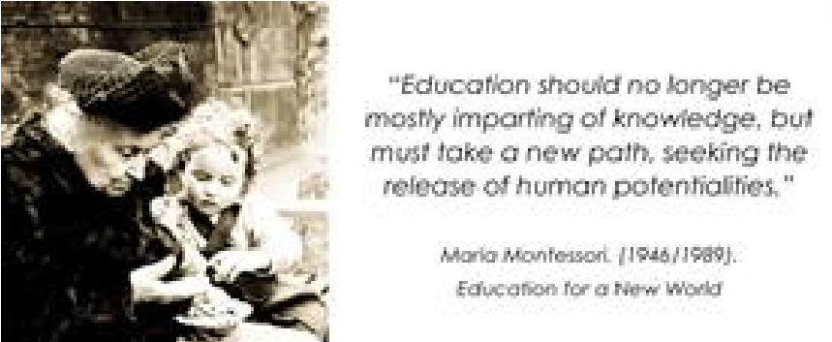

Breakout Selection Please indicate first, second and third choice for each

MORNING SESSION Saturday March 4th, 2023 (10:00am – 11:30am)
Choice #
____ 1 Folk Dance for Children – All Levels – Dr. Daniel Jutras
____ 2 Building a Montessori Professional Development Plan – Administration – Tammy Oesting
____ 3 Can Cosmic Education TRULY Build Academic Skills? A “How- to for Infusing Wonder and Curiosity into
Learning and Skill Development – Elementary – Claudia Mann
____ 4 Exploring Sensorial – All Levels – Jayanthi Rajagopalan

AFTERNOON SESSION Saturday March 4th, 2023 (1:30pm – 3:00pm)
Choice #
____ 1 Indigenizing the Montessori curriculum – adding indigenous Materials to the Montessori classroom
– All Levels – Cynthia Reimer
____ 2 The Three-Hour Work Cycle - Montessorians – Julia Lyras
____ 3 Singing with Young Children – 3-6 year olds – Allan Hirsh
____ 4 Practical Life Concepts are for Everyone, classroom and parents – 3-6 year olds – Tamera North
____ 5 Montessori Practices that Teach Peace and Mindfulness Shelf Work – All Levels – Tajali Tolan

AFTERNOON SESSION Saturday March 4th, 2023 (3:10pm – 4:40pm)
Choice #
____ 1 Tough to Treasured: How to Forge Positive Relationships Throughout Your Programs (and Life) – All Levels -
Claudia Mann
____ 2 Introducing Emotional Awareness and Mindfulness in the Child – All Levels – Shireen Albhai
____ 3 Festivals from around the World: Celebrating Diversity – All Levels – Jayanthi Rajagopalan/Anahita
Faroogh
____ 4 Circle Time Tool Box – 3-6 year olds – Allan Hirsh
____ 5 Triangulate Like Bees: Biomimicry Game for Elementary Students – Elementary – Tammy Oesting

AFTERNOON SESSION Saturday March 4th, 2023 (4:50pm – 6:00pm)
____ 1 Gathering of Administrators – Let’s share
____ 2 Let’s create a nomenclature – Non instructed – materials provided to create
____ 3 Exploring Yoga – All Levels - Anahita Faroogh

MORNING SESSION Sunday March 5th, 2023 (10:00am – 11:30am)
Choice #
____ 1 The Jenga Game or the Mirror of yourself in your Montessori classroom – All Levels – Dr. Daniel Jutras
____ 2 Yoga and Peace Circle – All Levels – Tajali Tolan
____ 3 Diversity and Parent Communication – Administration – Jayanthi Rajagopalan/Anahita Faroogh
____ 4 The Metis Flower Beadwork – All Levels - Cynthia Reimer

AFTERNOON SESSION Sunday March 5th, 2023 (12:15pm – 1:45pm)
Choice #
____ 1 The Ground Beneath Our Feet: Practical Application in Cosmic Education for Future Generations –
Elementary – Claudia Mann
____ 2 Introduction to a Leadership Mindset – Montessorians/Administration – Shireen Alibhai
____ 3 Building Number Sense – 1.5 – 7 year olds – Tammy Oesting
____ 4 Montessori and Autism – All Levels – Julie Lyras
____ 5 Sensory Bins the Montessori Way – 3-6 year olds – Jenna Mazzei

What will you be attending - Please circle Yes or No
Friday March 3
Welcoming Session/Keynote – Yes No
Saturday March 4
Sunrise Yoga Yes No
Continental Breakfast Yes No
Lunch Yes No
Dinner/Entertainment Yes No
Sunday March 5
Sunrise Yoga Yes No
Continental Breakfast Yes No
Lunch Yes No
We ask that you only register for Sunrise Yoga if you are going to attend it.
Exhibitors and Sponsors please select that tab to learn more information

Our Keynotes for Weekend:
Friday March 3 – 7:00pm to 8:00pm -Teach Empathy and Create Compassionate World. Another plug for kindness - ​​ Tajali Tolan
Saturday April 4 – 8:45am to 9:45pm – The Montessori Stereotype: Dissolving Illusions and Opening Minds – Jenna Mazzei
Saturday April 4 – 12:00pm – 1:00pm -
Sunday April 5 – 9:00am – 10:00am – Creating long -lasting impressions: The truth about tours - Tammy Oesting
Sunday April 5 – 1:55pm – 2:55pm - The “Enigmatic” Teacher guide – Daniel Jutras

Mail: Email Questions:
MCHA debaar@montessoriway.ca 403-863-3229
108, 2411 – 4th St NW
Calgary, Alberta T2M 2Z8

